TOURISM PLAN ANNEXURE T
Ubuntu Tourism Plan


A Ten Year Plan

2010 – 2020

Prepared and Presented by:


Table of Contents

- Executive Summary 3
- Background 4
- Tourism in perspective 7
- Competitive Analysis 8
- Status of Local Attractions 14

  - Victoria West
  - Richmond
  - Loxton

- Priority Tourism Sub-Sectors 22
- Tourism Strategies 25
- Tourism Projects 30
- Critical Success Factors 37
- Conclusion 37

1. Executive Summary
Following Council Resolution to transform Ubuntu into a viable tourist destination to improve local economy, Creative Harvest is pleased to present the Tourism Plan for Ubuntu Municipality projected over a ten year period. This strategy is developed under the auspices of key policy documents including: Ubuntu IDP, Pixley ka Seme District Municipality and the Northern Cape Growth and Development Strategy. This is in recognition of the immense contribution of tourism to the growth of the Province in general and in particular to the local economy.

The development of this Tourism Plan was further informed by stakeholders’ inputs through various mechanisms including a workshop that was held in Victoria West where stakeholders from all three constituent towns present. In addition to stakeholder inputs, there was site visitation undertaken of all the tourist attractions in the Municipality and photographic evidence of their current state included.

From the assessment undertaken of the tourism environment, it is evident that Ubuntu has an immense untapped potential to develop into a vibrant leisure tourist destination. However, there needs to be significant effort put into developing Ubuntu into a thriving tourist destination including: Focused Tourism Development, Restoration and listing of Heritage sites for tourism development purposes, active promotion of the municipality as a destination to create tourism demand, competent human resources to champion tourism in the municipality and tourism infrastructure development.

To achieve the preceding, a ten year tourism plan is proposed for implementation in three phases. Phase 1 will look into addressing the weakness mentioned thus transform the Municipality into a leisure tourism destination. Phase 2 will gravitate into retail tourism and Phase 3 will concentrate on developing Ubuntu into a MICE and general business tourist destination.

2. Background
Policy Basis of Tourism Plan
The basis of this plan was developed on the guidelines of the Northern Cape Tourism Development Policy, the Northern Cape Provincial Growth and Development Strategy (NCPGDS) together with the Pixley ka Seme growth and Development Strategy (PkSGDS) and Ubuntu IDP. This plan seeks to point out the following objectives for Ubuntu Tourism Development Plan:
- Transparency in all tourism strategies and actions undertaken.
- Protection and Preservation of the natural and cultural heritage to be fundamental to all future tourism development and marketing initiatives.
- Shared community participation and co-ordination on a continuous basis.
- Continuous communication and co-ordination among all tourism stakeholders in Ubuntu.
- Co-ordination and co-operation with surrounding towns, the provincial tourism bodies and other stakeholders.
- Accessibility and affordability of tourism facilities and services so that all community stakeholders can share in and enjoy the tourism experiences Ubuntu has to offer.

Tourism Challenges facing Ubuntu
The tourism challenges that emerged from the assessment of Ubuntu environment indicate the following limitations:
- Lack of clear and continuous planning and co-ordination of tourism.
- Inadequate tourism infrastructure.
- Inadequate human resource capacity to drive tourism development.
- Absence of proper tourism value chain co-ordination.
- Absence of active promotion of Ubuntu as a tourist destination.

Objective
The objective of this Tourism Plan is to transform the Municipal area into a prime tourist destination for local economic development.
To achieve the stated objective the following deliverables should be prioritised:
- To prioritise the development of tourism infrastructure in the constituent towns.
- To determine key tourism projects.
- To speed up the restoration of existing attractions and the development of new attractions.
- To promote pride in the cultural and natural heritage of the communities in Ubuntu.
- To promote community participation in tourism planning and development.
- To market Ubuntu as a tourism destination.
- Create opportunities for SMME development and employment through tourism development.

Methodology:
The methodology comprised a combination of factors including:
- A stakeholder workshop for stakeholders from all constituent towns, in Victoria West.
- Literature research including the PkSGDS, NC Tourism Strategy and the NCPGDS.
- Comparative assessment of other municipal tourism plans.
Prioritisation of the Tourism Sub-sectors:
Flowing from the assessment of Ubuntu, the following four sub-sectors were identified and prioritised:
Leisure Tourism – According to the assessment of Ubuntu leisure tourism is the leading sub-sector and thus receives strategic priority for development and implementation in the short term.
Retail Tourism – Ubuntu has exotic product including Karoo lamb, venison and game products, and unique Karoo crafts. This provides a good basis for Ubuntu to develop retail tourism over the medium term.
MICE Tourism – This is the fastest growing sector of the tourism market. Seeing that two of the towns in Ubuntu is strategically placed on main tourism routes (N1 and N12) make the area ideally placed for MICE tourism. It is suggested that the Municipality targets this sector for development over the long term.
General Business Tourism – This relates to individuals and groups travelling to do business. General business can include making sales and training. As the business hub for the area, Ubuntu is accessible for the general business tourist as two towns are situated on main tourist routes (N1 and N12) and an airfield is available. The Municipality should target general business tourism as a growth point over the long term.
Strategy
The strategy comprises multiple elements including the following:
Tourist Infrastructure Development – Establishment of adequate tourism infrastructure covering all constituent towns of Ubuntu Municipality.
Data Collection and Information Management – create an integrated all year round system for better tourist information collection and management.
Co-ordination of Tourism Value Chain – The co-ordination of the tourism value chain is a central function of tourism development as it ensures opportunities for SMME development and job creation. The municipality should play a lead role in the co-ordination of the value chain both upstream and downstream.
Heritage Restoration (Natural and Cultural) – The restoration and upgrade of the museums in Victoria West and Richmond as well as other sites.
Establishment of Special Purpose Vehicle (SPV) – In recognition of the fact that tourism development requires multiple players to flourish, it is necessary for the Municipality to facilitate the establishment of an SPV for better tourism planning, management and co-ordination.
Creating Demand – Active promotion of Ubuntu tourism products and services.
Identification and Development of New Tourist Attractions – over and above the existing attractions it is necessary for the Municipality to identify and develop new tourist attractions in order to strengthen the area as a prime leisure tourist destination.

3. Tourism in Perspective
This section deals with the importance of the contribution of tourism economy to local, national and international GDP and elevates tourism economy alongside the classical economic sectors.
Until 1999 tourism was not recognised as part of the formal economic sectors. The tourism economy needs to be conceived as an economic sector in the same way as the other 5 recognised sectors of the economy that is transport, manufacturing, services, mining and agriculture. Tourism is the fastest growing economic sector globally, growing at a staggering 9% per year over the last 10 years and being valued at $10 trillion by 2010.
Therefore in 1999 the World Tourism Organisation (WTO) launched tourism internationally as a fully fledged economic sector. In South Africa tourism contributed R69, 8 billion to the GDP in 1999. Looking at these statistics it is clear why tourism should be regarded as an economic sector of equal importance as the other five economic sectors.
The tourism industry can be described as having an indirect impact in the economy, guest sleeping over at Bed & Breakfast and paying for accommodation. The tourism economy comprises the direct and indirect demand of visitors. It has a far broader effect and clearly shows the knock-on effect of tourism economy. In view of this, greater importance must be placed on tourism development to achieve greater local economic outcomes. In what follows is the tourism structure that indicates the knock-on effect of the tourism industry on the broader tourism economy

Structure of Tourism Industry

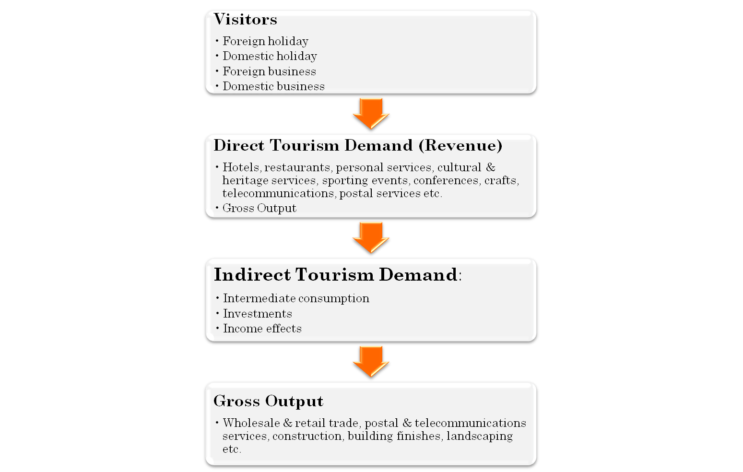
Indirect Tourism Value Added
Direct Tourism Value Added

4. Competitive Analysis
The following six factor framework is adopted to assess Ubuntu’s competitiveness as a tourist destination:

4.1 Factor Condition
People: Inadequate staff for the tourism office and a lack of a tourism champion to drive tourism development in Ubuntu negatively affects tourism development in the Municipality.
Resources: General lack of resources and tourism office.
Finance: It is the observation that tourism as a programme is neither planned nor adequately budgeted for.
Knowledge: Absence of accurate tourism information necessary to measure, plan and manage tourism further inhibits prospering tourism economy.
Infrastructure: Total absence of a dedicated and equipped one stop shop for tourism value chain which is necessary to provide tourism information both upstream and downstream.
Institution: Institutionally, no dedicated tourism office exists to drive tourism in the Municipality.
4.2 Value Chain Co-ordination
Tourism value chain is the co-ordination of upstream and downstream products and services.
It is noted that the value chain co-ordination is essential in tourism management as it provides SMME and local economic development opportunities along the value chain. The municipality plays a crucial role to ensure that the tourism value chain is well co-ordinated both upstream and downstream while at the same time affording space for private sector and community to fulfil their function in the value chain. It is unfortunate that given the deprioritisation of the tourism function in the Municipality, such crucial co-ordination is non-existent.

Below are the different factors that form part of the tourism value chain. Any lack of any of these factors result in poor value chain co-ordination.

4.3 Creating Demand
Tourism is about creating demand therefore marketing and promotion of a destination is vital in the development of a thriving tourism industry.
In the assessment of Ubuntu Municipality it was noticed that there is an absence of active marketing which has contributed to the inability to attract tourists. Ubuntu Municipality has further remained obscure despite the fact that it has great potential for a thriving tourism industry.
In the creation of demand it is important that we concentrate marketing efforts on the local market as opposed to the foreign market. In reality 60% of the tourism revenue in South Africa is accounted for by the local market as opposed to the international market. Thus the promotion of Ubuntu Municipality must assume central position in the development of local tourism economy.

4.4 Institutional Arrangement
The institutional arrangement raises the following weaknesses:
- Tourism Structure – There is a total lack of a proper human resource structure necessary to drive tourism. In the absence of a proper functional structure it will prove difficult to realise a flourishing tourism industry in Ubuntu.
- Tourism Infrastructure – There is a total lack of proper tourism infrastructure. No tourism office exists from where tourism can be managed.
There is an urgent need for the development of a tourism structure and infrastructure for the implementation of this plan.

4.5 Planning and Budgeting
At close observation there is sadly a lack of continued tourism planning supported by an adequate budget. In the current situation funds are allocated without any tourism business plan coupled with a budget. If Ubuntu is to achieve a vibrant tourism industry, concerted effort of an all year plan coupled with a budget is vital. Furthermore, if tourism is the major economic generator in the province, serious attention must be paid to the size of the budget allocated to tourism.

The preceding assessment points to the fact that tourism is de-prioritised and yet it remains the potential economic generator to turn around Ubuntu into a thriving tourist destination. It is necessary for the municipality to prioritise tourism through adequate staffing, proper infrastructure, proper budgeting and planning.

4.6 Location
The current situation without a dedicated tourism office or information centre is a reason for serious concern. The following needs urgent attention:
- Premises to house a tourism office and information centre that is user-friendly and easily accessible for tourists. The current trend is to keep the tourism office in its own premises and prominent to the tourist.
- With the consideration that especially Richmond is strategically situated on the N1, it is disappointing that there is no tourism information centre or office in the town. It is suggested that the Municipality considers establishing a tourism office or at least a proper information centre in this strategic town for tourism development.
4.7 Special Purpose Vehicle
The success of tourism is dependent on the participation of multiple players along the tourism value chain both upstream and downstream. It is therefore necessary for the Municipality to co-ordinate the establishment of a SPV that will serve as a co-ordinating vehicle for tourism planning, development and co-ordination among all key stakeholders.
The current assessment shows an absence of such a co-ordinating structure which is key to turn around Ubuntu into a tourism destination. The purpose of such a vehicle is to encourage involvement of all interested tourism stakeholders.
An SPV allows for an industry wide commitment, facilitates the harnessing of skills and pools resources to achieve better tourism outcomes.

The following SPV diagram illustrates partnerships with Private Sector, Communities and Municipality:

4.8 Tourism SWOT Analysis
Strengths | Weaknesses
- The Apollo Development in Victoria West  - The Karoo habitat as draw card for nature tourists  - Victoria West Museum excellent facility  - Good hiking trails  - The railway line that passes through the region  - Utilization of flying school air strip  - Local artist  - Good game farms  - Organized hunting industry  - Friendly inhabitants  - Ample accommodation  - Architecture of the region  - Safety  - Clean, pure air, clear skies  - Indigenous culture  - The N1 and the N12 services the region that ensures a large volume of traffic through the region | - The quality of some facilities is below what is desired  - Lack of recreational facilities  - Richmond museum needs attention / not in high quality  - Lack of petrol stations in Loxton  - No Marketing  - Lack of assign posts  - Poor roads for tourists  - Lack of Tourist information in the region  - Vandalism that causes the destruction of information boards  - Lack of tourist packages  - Long distances makes it difficult for tourists to visit the region  - Poor destination marketing  - Littering spoils the surroundings  - Race relations leaves much to be desired and impacts negatively on tourism  - Poor infrastructure in the townships hurts the tourism industry  - Water in Richmond is harsh on the palate

Opportunities | Threats
- Job creation through economic development  - Opportunity to sell bottled water to tourists  - Game farms can be mote optimally utilized  - Excess to information  - Huge opportunities do exist for inter-sectoral tourism  - Game farms can be more optimally utilized  - The tourism information offices of Ubuntu can be integrated in order to provide an improved service  - Recycling of all material  - Loxton needs a museum  - Upgrading of Caravan park in Loxton  - Marketing  - Upgrading of railway line that passes the region can benefit community | - Integration within the tourism sector and cooperation among people are not up to standard  - Alcohol abuse impact badly on tourism.  - Long distances  - Competition against other regions  - Duplication of services and facilities  - Name change  - Typical crime (patty crime)  - Lack of knowledge  - Protest marches with the blockage of roads impacts negatively on tourism and local businesses

5. Status of Local Tourism Attractions
The assessment undertaken in the municipality of the tourist attractions show a rather disappointing, neglected state of affairs. This state of disrepair diminishes the ability of the Municipality in becoming a tourist destination.

Below is a portfolio of photographic evidence showing the status of tourist attractions in the constituent towns of Ubuntu Municipality:

Victoria West
Victoria West Town Hall needs restoration and upgrading. It should be listed as a heritage site for tourism purposes.
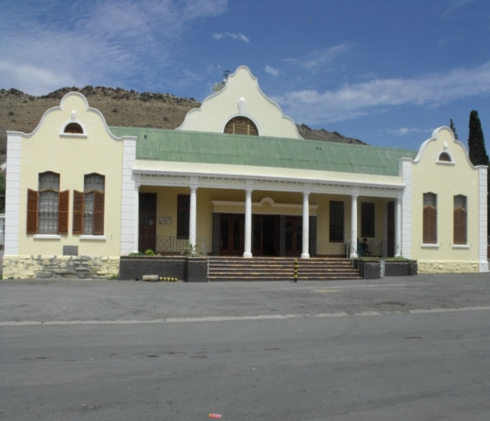
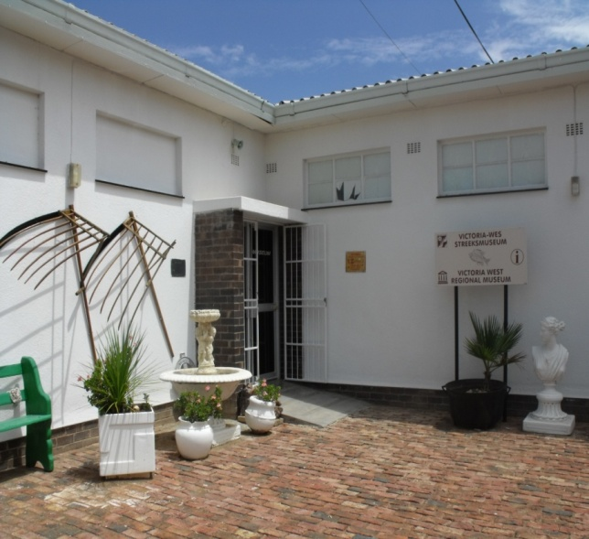
Victoria West Museum building needs restoration and proper signage especially at the entries of the town and at the building. This is the only purpose built museum in the province and one of the best museums. It should be properly signed and aggressive marketed as a tourist attraction.

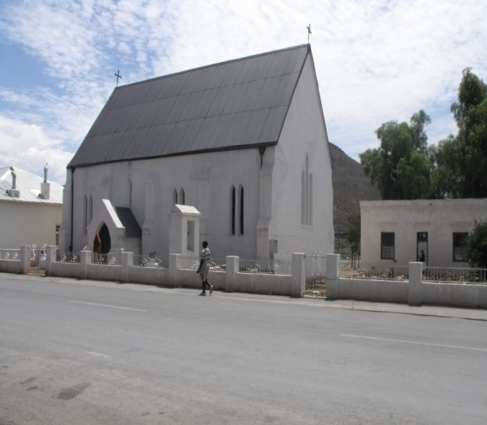

Anglican Church. This church was designed by Sophia Grey, the wife of Sir George Grey, Governor of the Cape. It is one of only a few remaining ‘Sophia Grey’ churches in the Northern Cape. In the process of being declared a heritage site.

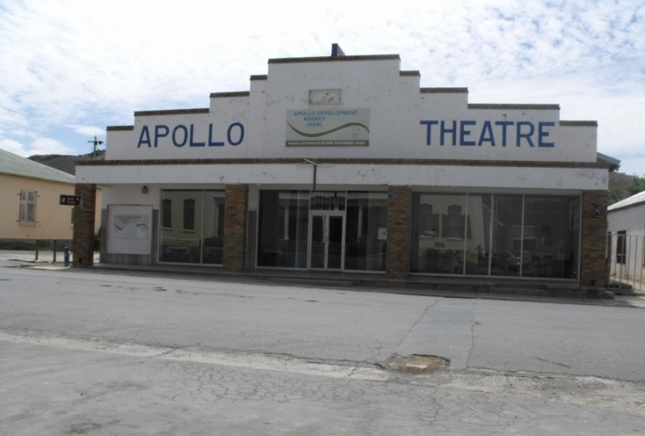

Apollo Theatre needs restoration urgently. This art deco building is ideally situated to utilise as a tourism office and information centre. The auditorium is a heritage site.
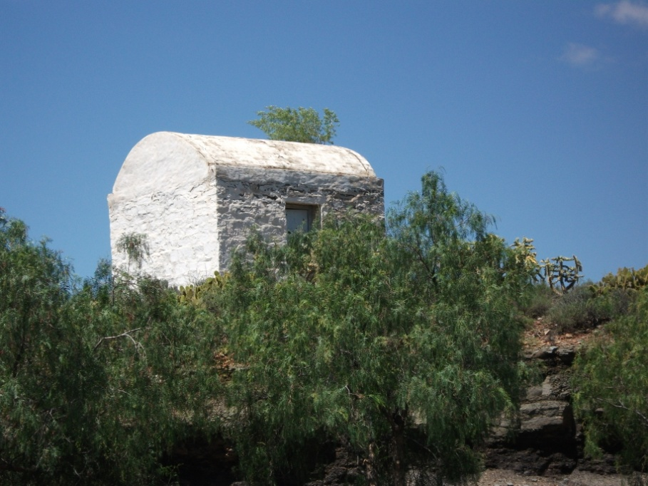

Gunpowder Magazine was used to store gunpowder/ammunition in the early years of Victoria West. This historic building urgently needs restoration. It should be listed as a heritage site for tourism development.

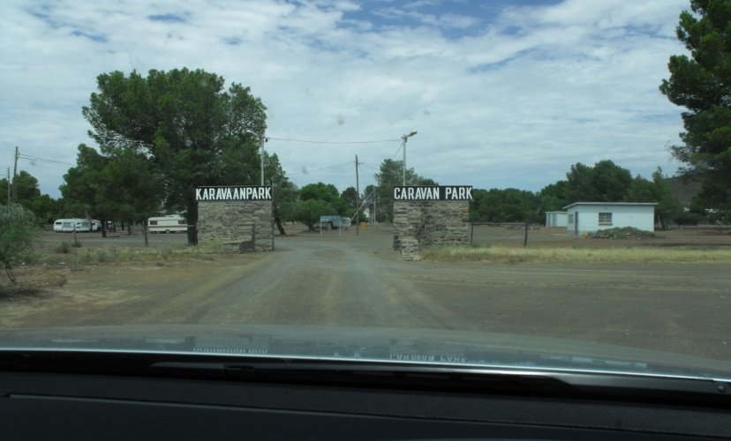

Victoria West Caravan Park is in a very bad state of disrepair. This park needs upgrading and marketing in order to develop Ubuntu into a prime tourist destination. Well maintained caravan parks can be utilised as draw cards for tourists to develop tourism in Ubuntu
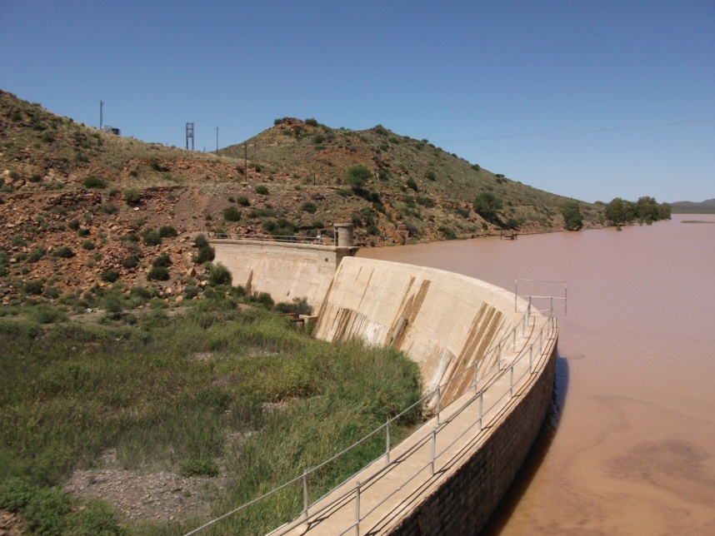
The Victoria West Dam. This site should be developed as a prime tourism attraction with picnic facilities as well as other amenities. The dam is linked with the game camp which needs to be developed into a conservation area.

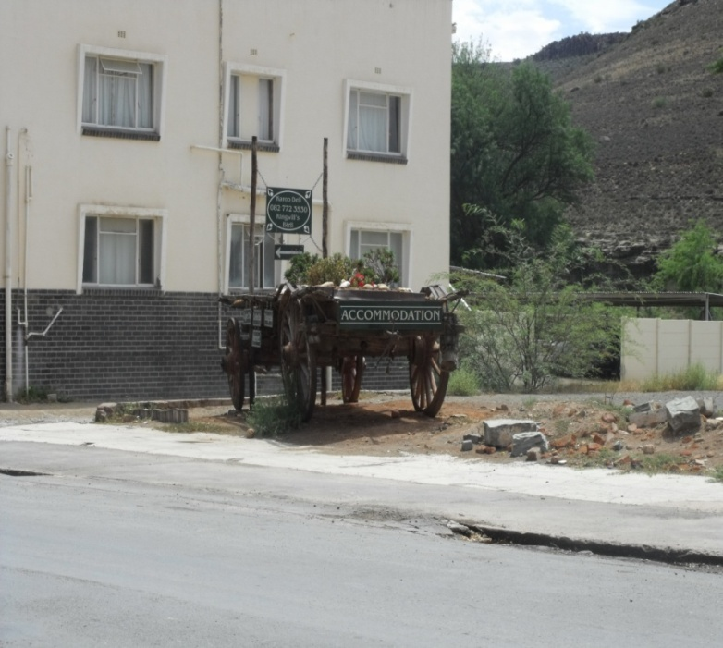
Clear signage to indicate accommodation establishments as well as other tourism attractions is vital in the development of Ubuntu into a prime tourist destination.

Richmond
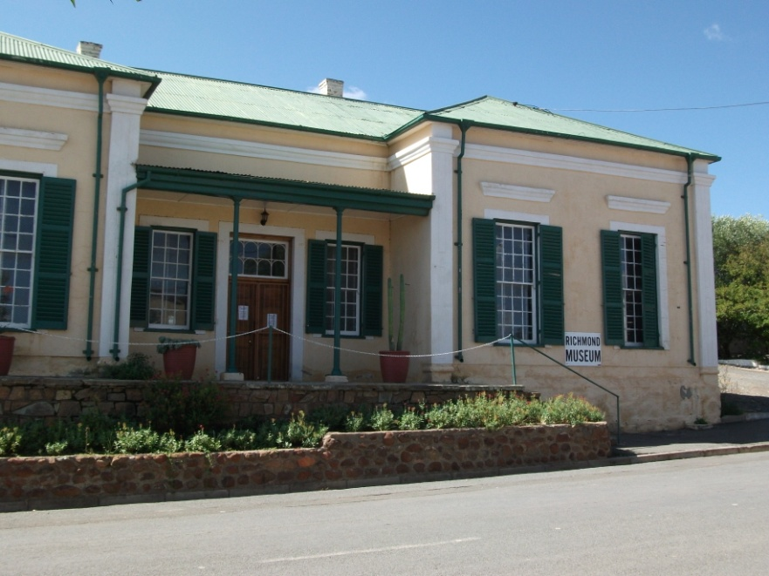
Richmond Museum. This is the only museum on racehorses in South Africa and one of only two in the world, however, no signage at the entries to the town indicate that a museum does exist. This building was the first school in Richmond and should be listed as a heritage site. The museum can be a major attraction for tourists in Ubuntu.

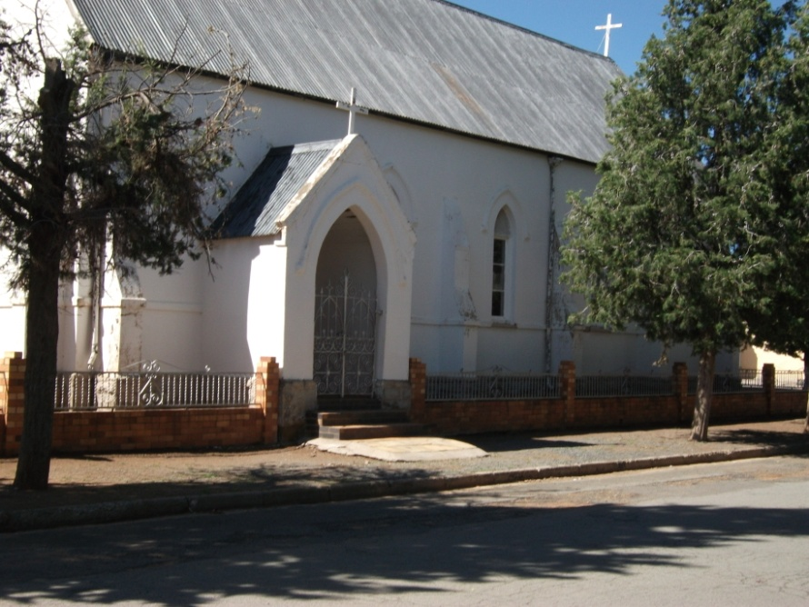
Anglican Church. This building is in need of restoration. It should be listed as a heritage site for tourism development.
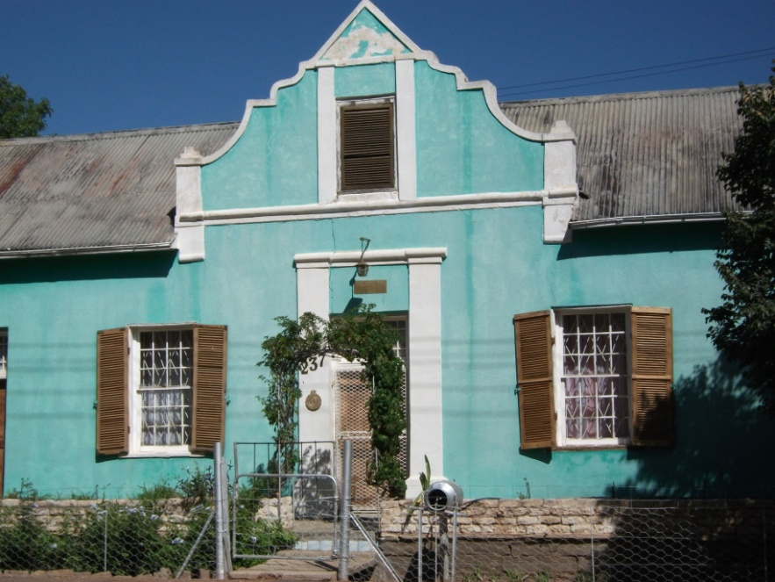

De Oude Dak was built in 1846 as the first house in the new town of Richmond. It is listed as a heritage site, but the building needs restoration like all the houses in this street. These are the oldest houses in Richmond and this area needs urgent restoration and listing as a heritage area for tourism development.

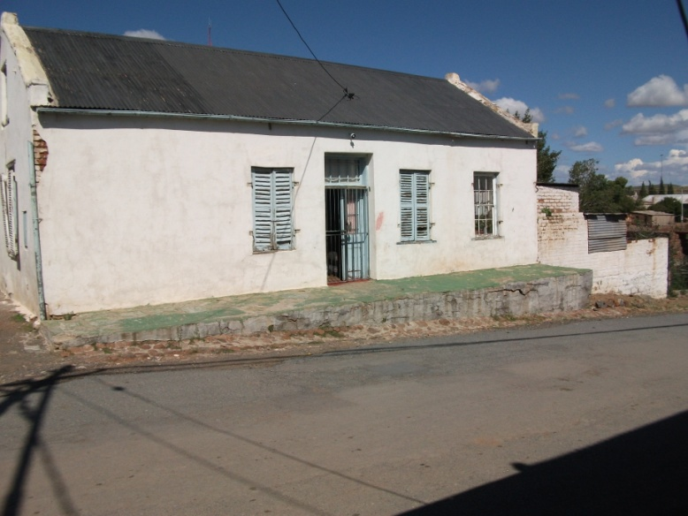

This was the home of the manager of Driefontein, the farm on which Richmond was founded. This house is one of the first houses seen as tourists enter Richmond, but is in s very bad state of disrepair. It needs restoration and listing as a heritage site.
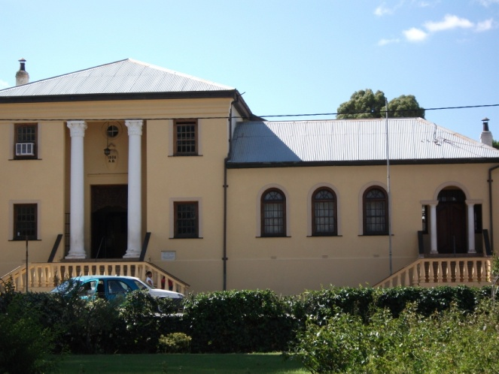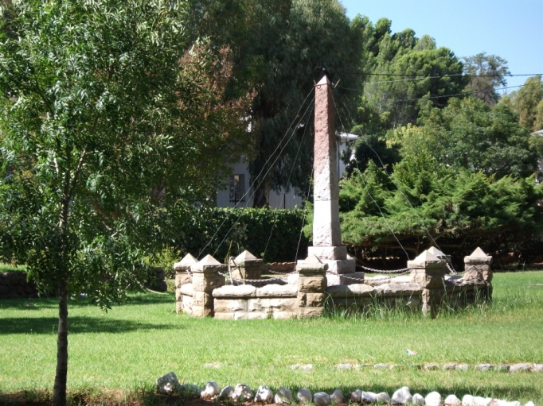

Richmond Town Hall and Municipal Office Building and the Town Square need restoration and upgrading. The Town Square still house the Town Bell which was rung to inform inhabitants of important events. Both should be listed as heritage sites.

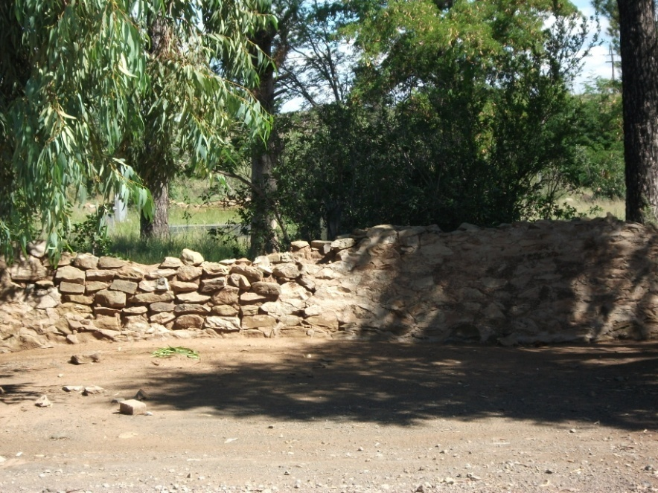

Stone walls – a unique feature of the Karoo. Richmond still has a few good examples. These should be maintained and listed as heritage sites.

Loxton
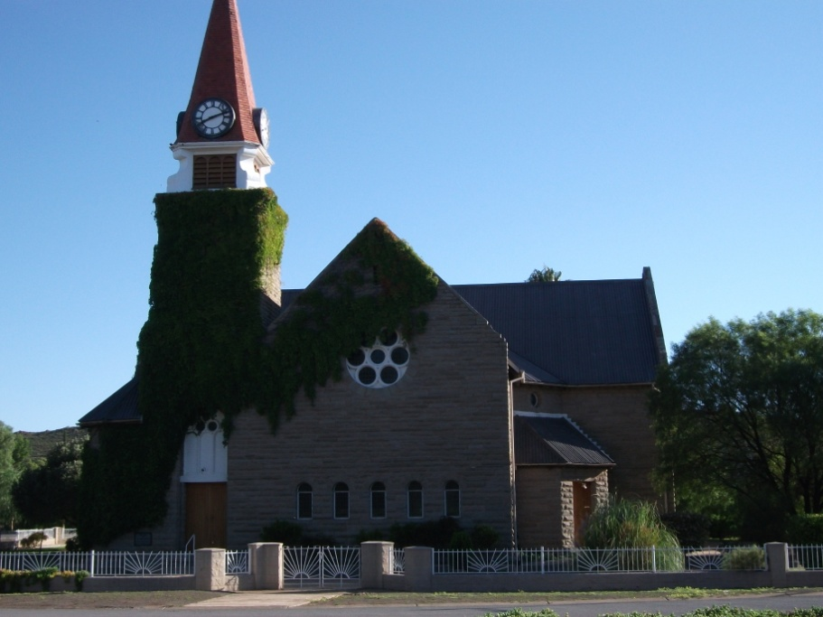
Loxton Dutch Reformed Church is an excellent example of the stone buildings of the Karoo. It is situated in the centre of the town and should be listed as a heritage site for tourism development.
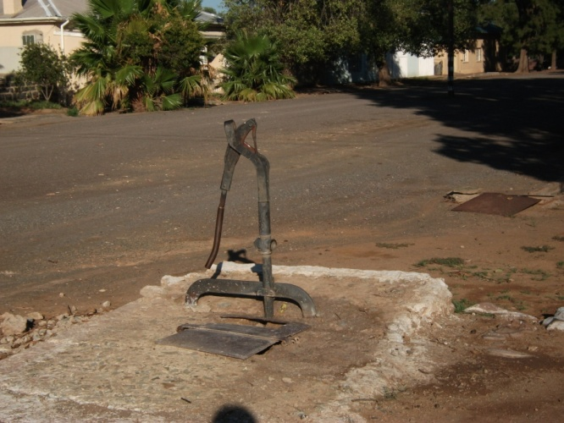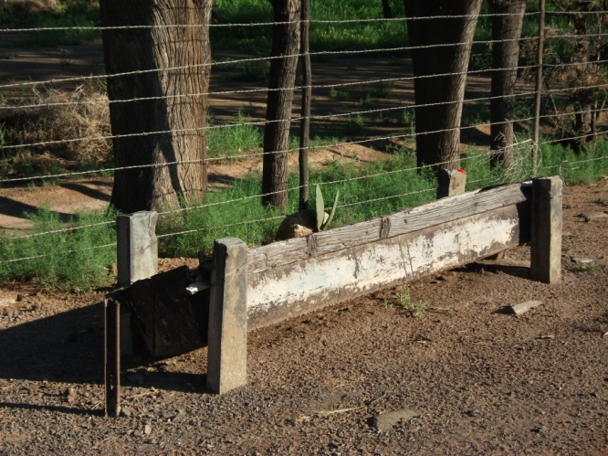
Water Pump and Trough on the sidewalk in Loxton.
This was facilities made available to horse owners, when they visited the town, to water their horses. Kids used to drink water at the hand pump on their way home after school. These are the only examples of such facilities which still exist in the District.
These items need urgent restoration and upgrading as well as signage. They should be listed as a heritage site for tourism development.

6. Priority Tourism Sub-Sectors
Tourism as an industry can be generally categorised into four Sub-sectors:
- Leisure Tourism – Holiday makers and holiday seekers
- Retail Tourism – To purchase goods
- MICE Tourism – Meetings, Incentives, Conferencing and Exhibitions
- General Business – Meetings, Training.
After a consultation and literature research this plan has emerged following tourism sub-sector priorities:
- Leisure Tourism
According to research and interaction with the stakeholders all indications are that leisure tourism is the strongest sub-sector in the area. According to the National and Provincial statistics of Tourism SA, leisure tourism is the strongest sub-sector in the province. We can accept that the same applies to Ubuntu Municipality as there are no statistics available.
Accordingly much effort and energy should be concentrated to developing Ubuntu as a leisure tourist destination. This will include the restoration of its cultural and natural heritage in collaboration with stakeholders including the farming community; SMME’s in tourism e.g. tour guides, crafters, cultural groups, etc.
The figure below illustrates that the Northern Cape Province is largely a leisure tourist destination and by association Ubuntu is also a leisure tourist destination.

Purpose of Visit | All Foreign Visitors | Province Visited
 |  | GP | WC | KZN | MP | EC | NW | FS | NC | NP
 | % | % | % | % | % | % | % | % | % | %
Holiday | 42 | 37 | 54 | 53 | 68 | 63 | 55 | 51 | 66 | 66
Business | 26 | 34 | 19 | 17 | 10 | 11 | 26 | 16 | 11 | 16
VFR | 22 | 22 | 20 | 22 | 18 | 18 | 16 | 28 | 15 | 15
Other | 8 | 7 | 7 | 8 | 4 | 8 | 3 | 5 | 8 | 3
All Foreign Visitors | 100 | 100 | 100 | 100 | 100 | 100 | 100 | 100 | 100

- Retail Tourism
The Karoo is privileged with diverse exotic products such as Karoo lamb, venison rare crafts, shins and hides, all of which has potential for retail. The municipality in collaboration with the community, farming community and SMME’s can further enhance these exotic products for retail.
It is proposed that this sub-sector be targeted as a tourism growth sub-sector over the next five years.

- MICE Tourism

MICE Tourism is the fastest growing tourism sub-sector in the tourism industry. As Victoria West is strategically located on the N12 and close to the N1, with an airfield, it is suggested that MICE tourism sub-sector be targeted as the growth point for tourism in the medium term.

The following business factors influence the need for the development of the MICE tourism sub-sector:
- Training
- Conferencing
- Planning
- Team building

The factors influencing the selection of a destination for MICE tourism are:
- Infrastructure conditions
- Facility availability
- Travel distances for attendees
- Image of the venue
- Value for money
- Reputation for high quality service
The Municipality needs to plan for the development of this sub-sector over the next five to seven years.
The following diagram illustrates MICE tourism as the fastest growing tourism sub-sector:

International breakdown:

The graph below illustrates MICE tourism nationally:

- General Business Tourism
Victoria West as the main town of Ubuntu and its location on the N12 is ideal to be developed as a general business tourism destination.
Necessarily certain conditions must be in place for this sub-sector to flourish including:
- Training facilities
- Sales and marketing opportunities
- SMME development

7. Tourism Strategy
Having assessed the tourism environment in the Municipality, we have emerged with a strategy to transform the Municipality into a thriving tourist destination for implementation over a ten year period.
7.1 Institutional Arrangement
A pointed out in the analysis section dealing with institutional arrangements, it is necessary for the Municipality to prioritise the following institutional factors:
- Recruitment of adequate and competent Human Resource to drive tourism.
- Establishment of a tourism office in Victoria West and a satellite office in Richmond.
- Consistent tourism planning coupled with adequate budget,
- It is suggested that this receives immediate priority.

7.2 Data Collection and Information Co-ordination
There needs to be an urgent prioritisation of tourism data collection which is necessary for better tourism planning and policy making. This will comprise the establishment of a data base in collaboration with all stakeholders. The SPV structure should play a pivotal role in the further co-ordination and management of tourism data. For this effort to succeed there needs to be optimal utilisation of technology for information management and co-ordination.
Following diagram illustrates the different process to obtain tourism information.

7.3 Co-ordination of the Tourism Value Chain
The co-ordination of the tourism value chain accounts for the most important activity in the development of tourism. Because the tourism value chain offers the possibility of job creation and opportunities for SMME’s the value chain both upstream and downstream can serves as information source/service to tourists.

Two critical factors are necessary for tourism value chain co-ordination. On the one hand a proper institutional arrangement is vital to ensure a well co-ordinated value chain. On the other hand the participation of the tourism stakeholders in providing products and services is important.
There need to be delineation of functions in order for the value chain to be co-ordinated. The municipality should provide the co-ordination function through its tourism information office. The private sector must provide services and products.
Again the success of co-ordination will be dependent on the proper functioning of the SPV.

The functioning of such a SPV will include:
- Design and implementation of information system.
- Membership to national and international organisations.
- Infrastructure constraints identification and motivation of intervention to Council.
- Opportunity identification for SMME’s.
- Value chain co-ordination issue identification and solutions
7.4 Creating Demand
Tourism is primarily a demand driven economic sector unless we sufficiently promote and market our tourism destination, it is impossible to increase demand for our tourism products and services. Indeed the active marketing of Ubuntu remains a priority.
Necessarily the effort to create demand is about rigorous marketing of our destination and this will include an integrated marketing and communication plan. In order to increase demand for Ubuntu Municipality there needs to be a strong marketing drive employing an integrated media strategy. This marketing and communication strategy will utilise the following media:
- Print : Tourism promotional brochure
- Digital
- Electronic

The scope of our marketing effort must be focused on the national tourism market and secondarily on the international market. This means our marketing strategy will be spread predominantly on the local market and in a lesser emphasis on the international market. This is in recognition of the fact that 60% of tourism is locally based.

7.5 Establishment of Special Purpose Vehicle
In recognition of the fact that tourism is a multiplayer game, it is suggested that a SPV comprising of all stakeholders be established with immediate effect. The SPV structure should lead in the broader development of tourism in the area as well as serve as a resource to plot new tourism opportunities within the municipality.
It is the role of the municipality to lead the formation of this structure without being too prescriptive. In this consideration the municipality’s role should be a facilitating one. It is further suggested that such a SPV structure convenes at least once per quarter that is four times per year. Its functions should include among others:
- Generation of new ideas for tourism development.
- Co-ordination and management of the tourism value chain.
- Identification of new tourism opportunities.
- Assisting in creating demand for local products and services.
- Job creation.
- SMME opportunities.
- Collaboration with provincial and national organisations.
The diagram below illustrates the relationship between the tourism stakeholders of Ubuntu including Council, and the community.

7.6 Heritage Restoration
As mentioned in the preceding sections of this plan, the current state of heritage in the Municipality is in dire straits and urgently needs restoration. Amongst the efforts required in heritage restoration is the physical upgrade of sites for aesthetic appeal as well as collection of new information, e.g. sites on the Khoisan heritage.
It is suggested that the Municipality prioritises the identification and listing of heritage sites to enhance the efforts for tourism development.
7.7 Development of New Attractions
Over and above the restoration of tourist attractions it is necessary to identify and develop new attractions in order to transform Ubuntu into a prime leisure tourism destination. The following are suggested tourism attractions for development at Ubuntu Municipality:
- Establishment of a museum for Loxton
- Hiking trails
- Camping sites
- Karoo Game route
- Development of Nature reserve
- Khoisan Rock Art route
- Hunting route
- Karoo Meander route
- Archaeological Route
- Karoo lamb route

8. Tourism Projects
Each suggested strategic objective will need to be considered in detail and developed further as a self-contained business plan for purposes of budgeting and implementation.
The tourism projects listed below comprise strategic activities targeted to improve leisure tourism in Ubuntu and are to be achieved over a three year period commencing 2010:
- Short term Objectives: 2010 – 2013

- Development of Tourism Infrastructure
- Institutional Arrangements
- Data Collection and tourism information co-ordination
- Establishing of SPV for value chain co-ordination
- Heritage Restoration
- Creating Demand
- Identification and creation of new attractions

8.1 Development of Tourism Infrastructure
Objectives
- Prioritise the establishment and development of tourism infrastructure to increase tourism demand for the destination.
Rationale
- For effective tourism development and promotion
Project description
- Establishment of a tourism office and information centre in Victoria West
- Establishment of a tourism office/info centre in Richmond and Loxton.
Cost Estimate
- It is projected that this will cost R1.5 million.
Timeframe
- The development of tourism infrastructure should be implemented over three years starting in 2010.

8.2 Institutional Arrangement
Objectives
- Prioritise tourism through improving institutional arrangement including Human Resource, planning and budget allocation.
Rationale
- A well championed tourism development programme.
Project Description
- Design appropriate structure to drive tourism development.
- Develop a proper planning process.
- Adequate budget allocation coupled with tourism planning.
Cost Estimate
- It is projected that this will cost R1.5 million.
Timeframe
- It is proposed that this project be undertaken immediately

8.3 Data Collection and Information Co-ordination
Objectives
- Better management of tourism information which is necessary for better co-ordination of the tourism value chain thus ensuring memorable tourism experience.
Rationale
- Accurate tourism information is necessary for better policy making and tourism planning.
Project Description
- Establish a database for tourism information
- Design a data collection instrument
- Collection of feedback from stakeholders on a monthly basis
- Inclusion of collected information in database
Cost Estimate
- It is projected that this project will cost R 500 000.00
Timeframe
- This project should be effected immediately

8.4 Establishment of SPV for Co-ordination
Objectives
- To establish a special purpose vehicle for proper co-ordination of the tourism value chain and management as well as to encourage a wider participation of stakeholders.
Rationale
- Recognition of multiple stakeholders necessary to ensure successful tourism development.
- To have an inclusive structure that will identify tourism opportunities for increased local economic development.
Project Description
- Facilitate a founding meeting with all the tourism stakeholders including community, SMME’s and private sector.
- In conjunction with the tourism stakeholders the SPC structure should determine the functions of the SPV and frequency of meetings. In this consideration the municipality will play a facilitating role.
Cost Estimate
- It is projected that this project will cost R 500 000.00
Timeframe
- It is proposed such a structure be established with immediate effect.
8.5 Heritage Restoration
Objectives
- To improve tourist attractions in order to increase tourist demand for the destination..
Rationale
- Currently attractions need restoration as this affects the demand for the destination.
Project Description
- Reconstruction of Khoisan heritage and other African cultural heritage existing in Ubuntu.
- Restoration of museum buildings and collections in Richmond and Victoria West museums.
- Upgrading of Moonlight Hill hiking trail.
- Restoration of powder magazine in Victoria West.
- Re-opening of the Apollo Film Theatre and film festival.
- A need exists to formalise the history of the indigenous people of the area and mainstream it in the history of the Municipality to create diverse and rich heritage.
Cost Estimate
- It is projected that this project will cost R5 million.
Timeframe
- The reconstruction of heritage should be implemented over the next three years commencing in 2010.
8.6 Creating Demand
Objective
- To transform Ubuntu into a prime tourist destination for local economic development.

Rationale
- To position the municipality as a preferred destination for leisure tourism.
- To increase SMME opportunities as well as job opportunities.
- To increase demand for tourism products and services.
- To match our tourist products and services to the market.
Project Description
- Embark on an aggressive marketing campaign utilising an integrated media and communication plan employing a spread of media tactics including digital, electronic, print, etc.
- The scope of the marketing will be predominantly national in recognition of the Sho’t left campaign.
Cost Estimate
- It is projected that this project will cost R1, 5 million.
Timeframe
- It is proposed project be undertaken in 2010 and 2011.
8.7 Identification and Development of New Tourist Attractions
Objective
- To identify and develop new tourist attractions for competitiveness.
Rationale
- To increase tourism competitiveness of Ubuntu Municipality.
Project Description
The identification and development of the proposed new attractions should be coupled with private sector participation through the SPV:
- Springbok Route
- Sheep Shearing Route
- Khoisan Rock Art and Archaeological Route
- Camping sites and hiking trails ( Victoria West Dam)
- Game Festival
- Ubuntu Tour Packages
Timeframe
- Some attractions could be developed in the short-term, while others could be developed in the medium- to long-term.

- Medium Term Objective 2013 to 2016
Retail and MICE tourism as sub-sectors should be targeted for growth in Ubuntu.
The MICE tourism sub-sector is dependent on the following factors:
- Facility availability
- Reputation for high quality service
- Travel distance for attendees
- Image of the venue
- Price
- Value for money
- Weather
- Activities offered
- Accessibility

- Long Term Objectives 2016 – 2020
General business tourism.
- Over the long term it is suggested that the municipality gravitates to develop retail and general business tourism sub sectors.
- The conditions to ensure success of these sub-sectors are:
- Business cycle of country and area
- Head quarter establishment
- Office space availability
- Training facilities
- Sales and marketing opportunities
- Product rage for retail purposes
- Agri-villages
- Product route, e.g. Mutton route, Springbok route, etc.
- Wide range of services

9. Critical Success Factors
In order for this plan to success and turn Ubuntu into a flourishing tourism destination the following factors are fundamental:
- Support and buy in of Council and top management is essential.
- Adequate budget allocation coupled with proper planning.
- Adequate human resource competency to drive tourism development.
- Full participation of all stakeholders in the tourism development process.
- The plan must be consistently implemented over the stipulated period if it is to achieve the desired outcomes.

10. Conclusion
This plan is proposed as a working document for consistent implementation over a 10 year period effective from 2010. Sufficient rigorous thinking and wide consultation have been undertaken to consider the suggested strategies to be considered invaluable, valid, creative, forward looking, visionary, inherently consistent with a methodological rigor and a set of action plans that can achieve the vision of transforming Ubuntu into a thriving tourist destination.
Each suggested strategic objective will need to be considered in detail and developed further into self-contained business plans for purposes of budgeting and implementation.
Collectively, the strategic thrusts presented, present a road map of how Ubuntu can further create job opportunities, SMME development and thus increased local economic value through a rigorous pursuit of tourism development.

It is our considered view that whereas there is room for continuous alignment and perhaps even adjustment of the proposed strategic pillars, it is strongly suggested that the Municipality does not eliminate any of these as this will fundamentally undermine the outcome of the plan.
Any piecemeal approach to this industry will result in failure to achieve the desired outcomes.
Finally, Ubuntu Municipality is urged to consider paying specific attention to the critical success factors fundamental to the success of this plan, including:
- The unequivocal support of Council.
- Improved planning and budgeting for tourism development.
- Stakeholder involvement.
- Acquisition of adequate and competent human resources to drive tourism development.

